Abstract template for the 1st IMC (San Pedro de Atacama, Chile)

Gabriel Ureta^{1,2,3}, José Pablo Sepúlveda⁴, Amiel Nieto¹, Pablo Salas¹ and Ivana Torres⁵

¹ Millennium Institute on Volcanic Risk Research – Ckelar Volcanoes, Antofagasta, Chile. gabriel.ureta@ckelar.org
² Universidad Católica del Norte, Departamento de Ciencias Geológicas, Antofagasta, Chile
³ Centro Nacional de Investigación para la Gestión Integrada del Riesgo de Desastres Santiago, Chile
⁴ Dipartimento di Scienze della Terra, Università degli studi di Firenze, Florence, Italy
⁵ University of Missouri - Kansas City, USA

Keywords: insert, three, keywords.

This template is an example of how to prepare an abstract for the 1st International Monogenetic Conference to be held on 4 – 8 November 2024 (San Pedro de Atacama, Chile). The simplest way to comply with the requested abstract format is to replace the text in this template with your text.
The title must be in Arial 14 pt bold font.
The Authors’ names must be be in Arial 9 pt font, with the presenting Author (either for oral or poster presentation) in boldface.
The Authors’ affiliations must be in Arial 8 pt italic font. The email address of the presenting Author is requested, and he/she will be referred to also as the Corresponding Author.
Three Keywords must be supplied in Arial 8 pt font.
The main text must be in Times New Roman 10 pt font.
Black/white and greyscale graphics/figures are allowed and welcome. Figures can be either one column-wide (7.5 cm) or two column-wide (between 7.5 and 16 cm). Any figure should be inserted in the text as a JPG file with 300 dpi resolution.
A brief paragraph with Acknowledgements may be added at the end of the main text.
A limited number of citations in the text are welcome, and the relevant list of references must be added at the end of the abstract. The ways to cite in the text are: Alighieri (1321), for single-author papers; Steno and Hutton (1680), for two-author papers; Buonarroti et al. (1505), if the authors are more than two. The reference format is shown in the Reference paragraph at the end of this template.
The length of the abstract cannot exceed two pages in this format. On the other hand, the Authors are strongly encouraged to submit informative abstracts longer than a single page.
The abstract should be submitted as a Word file with embedded figures (images), but the file size should not exceed 5 Mb in order to facilitate the upload process.
The abstract must be uploaded by June 15, 2024, using the 1st IMC website/email (monogeneticconference2024@ckelar.org). Together with the abstract, the Authors must indicate in the Registration Form (available at website and Second Circular) their preferred mode of presentation, either oral or poster. The Organizing Committee will allocate a limited number of oral presentations, with the remainder as posters. Thus, some presentations proposed as oral by the Authors could turn to posters, while no presentations proposed as posters by the Authors will become oral presentations without permission from the Corresponding Author. There is a limit of a MAXIMUM of ONE Oral and ONE POSTER presentations per registered (paid) participant.

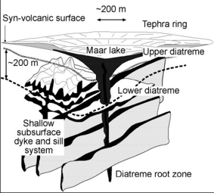
Fig. 1 – The caption(s) of the figure(s) should be typed in this format. The font to be used is Arial 8 pt.

This sentence is written just to fill the available space and contains no useful information for the abstract submission. This sentence is written just to fill the available space and contains no useful information for the abstract submission. This sentence is written just to fill the available space and contains no useful information for the abstract submission. This sentence is written just to fill the available space and contains no useful information for the abstract submission.
This sentence is written just to fill the available space and contains no useful information for the abstract submission. This sentence is written just to fill the available space and contains no useful information for the abstract submission. This sentence is written just to fill the available space and contains no useful information for the abstract submission. This sentence is written just to fill the available space and contains no useful information for the abstract submission.

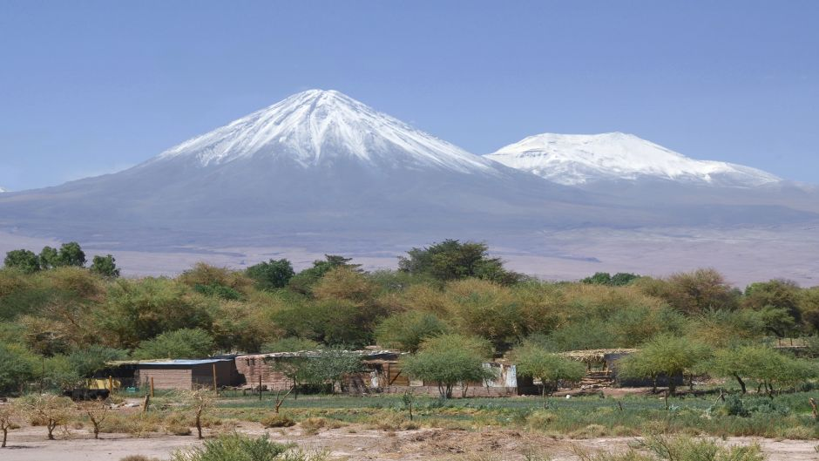Fig. 2 – The caption(s) of the figure(s) should be typed in this format. The font to be used is Arial 8 pt.

This sentence is written just to fill the available space and contains no useful information for the abstract submission. This sentence is written just to fill the available space and contains no useful information for the abstract submission. This sentence is written just to fill the available space and contains no useful information.
This sentence is written just to fill the available space and contains no useful information for the abstract submission. This sentence is written just to fill the available space and contains no useful information for the abstract submission. This sentence is written just to fill the available space and contains no useful information for the abstract submission. This sentence is written just to fill the available space and contains no useful information for the abstract submission. This sentence is written just to fill the available space and contains no useful information for the abstract submission. This sentence is written just to fill the available space and contains no useful information for the abstract submission. This sentence is written just to fill the available space and contains no useful information for the abstract submission. This sentence is written just to fill the available space and contains no useful information for the abstract submission.

Acknowledgements

All the Authors are kindly thanked for having submitted an abstract formatted according to this template.

References

Bebbington, M.S., Cronin, S.J. 2010. Spatio-temporal hazard estimation in the Auckland Volcanic Field, New Zealand, with a new event-order model. Bulletin of Volcanology DOI: 10.1007/s00445-010-0403-6.
Cassidy, J., Locke, C.A, 2010. The Auckland volcanic field, New Zealand: Geophysical evidence for structural and spatio-temporal relationships. Journal of Volcanology and Geothermal Research 195: 127-137.
Lindsay, J., Marzocchi, W., Jolly, G., 2010. Towards real-time eruption forecasting in the Auckland Volcanic Field: application of BET_EF during the New Zealand National Disaster Exercise 'Ruaumoko'. Bulletin of Volcanology 72: 185-204.
Magill, C.R., McAneney, K.J., Smith, I.E.M., 2001. Probabilistic assessment of vent locations for the next Auckland volcanic field event. Mathematical Geology 37: 227-242.
Molloy, C., Shane, P., Augustinus, P., 2009. Eruption recurrence rates in a basaltic volcanic field based on tephra layers in maar sediments: Implications for hazards in the Auckland volcanic field. Geological Society of America Bulletin 121: 1666-1677.
Németh, K., 2010. Monogenetic volcanic fields: Origin, sedimentary record, and relationship with polygenetic volcanism, in Cañón-Tapia, E., and Szakács, A., eds., What Is a Volcano? Geological Society of America Special Paper 470: 43–66.
Sherburn, S., Scott, B.J., Olsen, J., Miller, C. 2007. Monitoring seismic precursors to an eruption from the Auckland Volcanic Field, New Zealand. New Zealand Journal of Geology and Geophysics 50: 1-11.
Smith, I.E.M., Blake, S., Wilson, C.J.N., Houghton, B.F. 2008. Deep-seated fractionation during the rise of a small-volume basalt magma batch: Crater Hill, Auckland, New Zealand. Contributions to Mineralogy and Petrology 3155: 511-527.
von Veh, M,W., Németh, K., 2009. An assessment of the alignments of vents on geostatistical analysis in the Auckland Volcanic Field, New Zealand. Géomorphologie – Relief, Processus, Environment 2009/3:.175-186.

